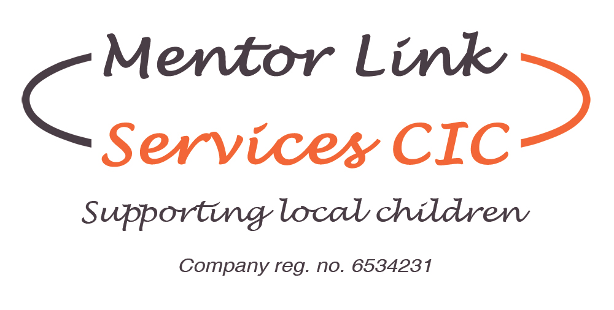

Volunteer Application Form

Title ……………Surname………………………First name……………………….

Address……………………………………………………………………………….....

…………………………………………………………………………………………..

Postcode…………………….

Date of Birth………………...

Telephone Number…………………………..Mobile………………………………….

E Mail………………………………………………

Do you have a full driving licence? Yes/No

Do you own a vehicle Yes/No

Name of next of kin in case of emergency

Title……………Surname…………………First Name ……………………………….

Relationship………………………………..

Telephone number……………………………………

Are you currently employed? Yes/No

If Yes is this part time or full time? Part/full

Employer’s name, address and your job title.

Name……………………………………………………………………………………

Address…………………………………………………………………………………

Job Title………………………………………………………………………………
Brief outline of duties if employed ………………………………………………….

…………………………………………………………………………………………

…………………………………………………………………………………………

Please indicate how much time you have available each week

…………………………………………………………….

Do you have any previous experience of voluntary work? Yes/no

If yes- please give details

……………………………………………………………..

Do you have any experience of working within a charity shop?

………………………………………………………………………………………..

What skills do you think you can bring to the role of a Volunteer?

.........................................................................................................................

We have opportunities for sorting, arranging, cleaning, pricing and selling stock – please indicate if you have any preferences for which area you would like to volunteer for.................................................................................................................................

Do you have any hobbies?.........................................................................................

References

Please give details of two referees who are able to support your application.

Name………………………………. Name……………………………….

Address……………………………... Address……………………………...

……………………………………… …………………………………….

Postcode…………………………….. Postcode…………………………….

Telephone number……………………Telephone number…………………..

Relationship………………………….. Relationship………………………..

DISABILITY
Do you consider that you have a disability?

YES □ NO □ Prefer not to say □
If so, please give brief details of the disability and any adjustments that would need to be made to enable you to carry out the duties listed for this role.(continue on a separate sheet if necessary)

Declaration
I declare that the information given on this form is correct.

Signed…………………………… Date………………………………..

Please return to:

Bridget Hood
Mentor Link Services CIC
c/o 18 Lombard Street
Stourport on Severn
DY13 8DT

marked “Private and Confidential”

Telephone: 01299 822336

